Load Balance Web Application Practice
- Schedule 限定每次僅一個instance能夠執行
- 建立 TC_SCHEDULE table
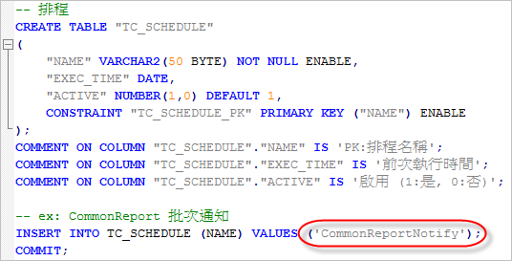

- 在排程中加上判斷
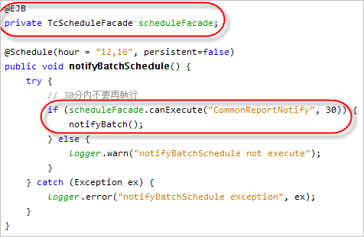

- JPA cache 同步: eclipselink cache coordinate with jms (ActiveMQ)
Glassfish 設定:
- 部署ActiveMQ RAR:登入glassfish主控台, 應用程式 > 部署activemq-rar-tcc-5.5.1.rar(原本的activemq-rar-5.5.1.rar加上slf4j-api-1.6.1.jar, slf4j-log4j12-1.6.1.jar)
- 資源 > 資源配接卡配置 > 新增
資源配接卡名稱: activemq-rar-tcc-5.5.1
執行緒池 ID: thread-pool-1
ServerUrl: failover(tcp://192.168.203.81:61616)
其它不改

程式設定:
persistence.xml
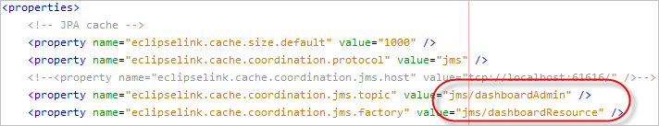
ps:將protocol那行mark掉就不會啟用cache coordinate機制。jms.host可以不用設，會去抓資源配接卡ServerUrl設定，PROD/QA/TEST可以用相同設定。但glassfish停掉時會出現exception (應該沒有影響)。

glassfish-resources.xml
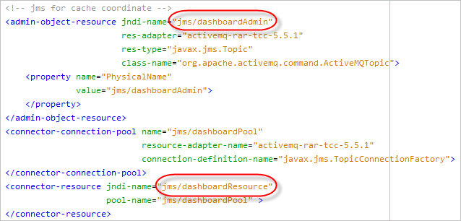

設定完成及部署後，glassfish admin console如下:
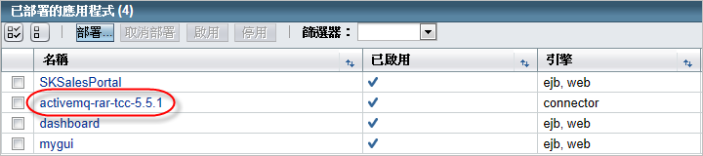
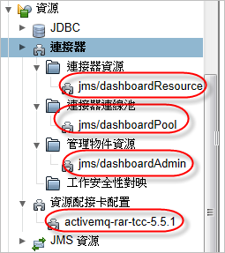

Deploy resources tip:
resources.conf (測試機)
# asadmin --host 192.168.203.81 --user admin multimode --file resources.conf

# jdbc, jndi config
# delete-jdbc-resource jdbc/dashboard
# delete-jdbc-connection-pool dashboardPool
delete-custom-resource jndi/dashboard.config
add-resources glassfish-resources.xml

# SAM config
delete-message-security-provider --layer HttpServlet SAM_DASHBOARD
create-message-security-provider --layer HttpServlet --classname com.tcci.cas.sam.CasServerAuthModule --providertype server --property defaultGroup="Authenticated":casServerLoginUrl="${com.taiwancement.sso.loginUrl }":casServerUrlPrefix="${com.taiwancement.sso.serverUrlPrefix}":jaas-context="casRealm":jndi-dataSource="jdbc/dashboard":query-group="select g.code from TC_User u, TC_USERGROUP gu,TC_GROUP g where u.login_account\=? and u.id\=gu.user_id and gu.GROUP_ID\=g.id":serverName="192.168.203.81" SAM_DASHBOARD

Glassfish-resource.xml(測試機)
<?xml version="1.0" encoding="UTF-8"?>
<!DOCTYPE resources PUBLIC "-//GlassFish.org//DTD GlassFish Application Server 3.1 Resource Definitions//EN" "http://glassfish.org/dtds/glassfish-resources_1_5.dtd">
<resources>
<jdbc-connection-pool name="dashboardPool"
res-type="javax.sql.DataSource"
datasource-classname="oracle.jdbc.pool.OracleDataSource"
steady-pool-size="8"
max-pool-size="32"
pool-resize-quantity="2"
idle-timeout-in-seconds="300"
max-wait-time-in-millis="60000"
non-transactional-connections="false"
is-isolation-level-guaranteed="true"
statement-timeout-in-seconds="-1"
statement-cache-size="0"
wrap-jdbc-objects="false"
pooling="true"
validate-atmost-once-period-in-seconds="0"
connection-leak-timeout-in-seconds="0"
connection-leak-reclaim="false"
connection-creation-retry-attempts="0"
connection-creation-retry-interval-in-seconds="10"
lazy-connection-association="false"
lazy-connection-enlistment="false"
associate-with-thread="false"
match-connections="false"
max-connection-usage-count="0"
is-connection-validation-required="true"
connection-validation-method="auto-commit"
fail-all-connections="true"
allow-non-component-callers="false" >
<property name="URL" value="jdbc:oracle:thin:@192.168.203.81:1521:orcl"></property>
<property name="user" value="dashboard_user"></property>
<property name="password" value="${ALIAS=db_pw_dashboard}"></property>
</jdbc-connection-pool>
<jdbc-resource pool-name="dashboardPool" jndi-name="jdbc/dashboard"></jdbc-resource>
<custom-resource res-type="java.util.Properties" jndi-name="jndi/dashboard.config" factory-class="org.glassfish.resources.custom.factory.PropertiesFactory">
<property name="appURL" value="http://192.168.203.81/dashboard"></property>
</custom-resource>
</resources>

resources-qa.conf (QA機)
# asadmin --host 192.168.203.62 --user admin --passwordfile ../../pwd_QA.properties multimode --file resources-qa.conf

# jdbc, jndi config
# delete-jdbc-resource jdbc/dashboard
# delete-jdbc-connection-pool dashboardPool
delete-custom-resource jndi/dashboard.config
add-resources glassfish-resources-qa.xml

# SAM config
delete-message-security-provider --layer HttpServlet SAM_DASHBOARD
create-message-security-provider --layer HttpServlet --classname com.tcci.cas.sam.CasServerAuthModule --providertype server --property defaultGroup="Authenticated":casServerLoginUrl="${com.taiwancement.sso.loginUrl}":casServerUrlPrefix="${com.taiwancement.sso.serverUrlPrefix }":jaas-context="casRealm":jndi-dataSource="jdbc/dashboard":query-group="select g.code from TC_User u, TC_USERGROUP gu,TC_GROUP g where u.login_account\=? and u.id\=gu.user_id and gu.GROUP_ID\=g.id":serverName="192.168.203.62" SAM_DASHBOARD

Glassfish-resource.xml(QA機)
<?xml version="1.0" encoding="UTF-8"?>
<!DOCTYPE resources PUBLIC "-//GlassFish.org//DTD GlassFish Application Server 3.1 Resource Definitions//EN" "http://glassfish.org/dtds/glassfish-resources_1_5.dtd">
<resources>
<jdbc-connection-pool name="dashboardPool"
res-type="javax.sql.DataSource"
datasource-classname="oracle.jdbc.pool.OracleDataSource"
steady-pool-size="8"
max-pool-size="32"
pool-resize-quantity="2"
idle-timeout-in-seconds="300"
max-wait-time-in-millis="60000"
non-transactional-connections="false"
is-isolation-level-guaranteed="true"
statement-timeout-in-seconds="-1"
statement-cache-size="0"
wrap-jdbc-objects="false"
pooling="true"
validate-atmost-once-period-in-seconds="0"
connection-leak-timeout-in-seconds="0"
connection-leak-reclaim="false"
connection-creation-retry-attempts="0"
connection-creation-retry-interval-in-seconds="10"
lazy-connection-association="false"
lazy-connection-enlistment="false"
associate-with-thread="false"
match-connections="false"
max-connection-usage-count="0"
is-connection-validation-required="true"
connection-validation-method="auto-commit"
fail-all-connections="true"
allow-non-component-callers="false" >
<property name="URL" value="jdbc:oracle:thin:@192.168.203.62:1521:orcl"></property>
<property name="user" value="dashboard_user"></property>
<property name="password" value="${ALIAS=db_pw_dashboard}"></property>
</jdbc-connection-pool>
<jdbc-resource pool-name="dashboardPool" jndi-name="jdbc/dashboard"></jdbc-resource>
<custom-resource res-type="java.util.Properties" jndi-name="jndi/dashboard.config" factory-class="org.glassfish.resources.custom.factory.PropertiesFactory">
<property name="appURL" value="http://192.168.203.62/dashboard"></property>
</custom-resource>
</resources>

pwd_QA.properties
AS_ADMIN_PASSWORD=abcd1234

